ASQ Rochester Newsletter — April 2026

ASQ Rochester Newsletter — April 2026

As Chair, I’m proud of the energy and accomplishments our chapter has shown through the first third of the year. We launched an RIT student chapter, saw strong student performances at Data Fest, celebrated outstanding robotics competition results, and built a full calendar of upcoming events that connect professionals, students, and local industry. These activities embody our commitment to advancing quality through education, collaboration, and practical application. I encourage everyone to volunteer, attend events, and welcome new members as we build momentum toward the Fall Conference and national gatherings later this year.

Starting an RIT Student Chapter
We’re excited to announce the launch of an ASQ Student Chapter at RIT. This new chapter will strengthen connections between students and quality professionals, create hands-on project opportunities, and open pathways for student membership, certifications, and local networking. The chapter will host workshops on basic quality tools, Lean methods, and Six Sigma fundamentals, and plans to run mentorship pairings between students and local industry volunteers. Faculty advisors and chapter officers are already coordinating a semester calendar that includes guest speakers and site visits to regional manufacturing and service organizations. The inaugural meeting was held on Thursday, April 23 at RIT’s Hugh L Carey Hall.

FIRST Robotics Competition at RIT (March 12–14)
RIT hosted the FIRST Robotics regional competition, where Team 3173 McQuaid won Regional Alliance honors and Team 1126 SPARX were recognized for high scoring. Congratulations to the teams and volunteers for another successful regional event showcasing engineering, teamwork, and continuous improvement. Dozens of teams from across the region demonstrated iterative design, rapid problem solving, and robust testing practices, all core principles of quality engineering. Community volunteers supported judging, safety inspection, and awards ceremonies, helping ensure a fair, educational competitive environment.
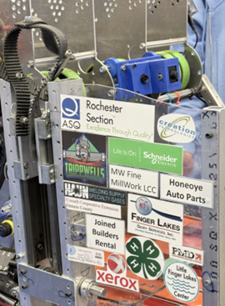

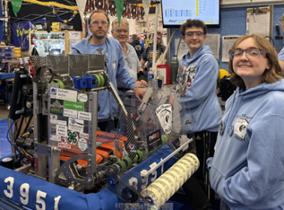

RIT Student Chapter at RIT Data Fest (March 27–29)
The student chapter competed in RIT’s Data Fest using a dataset of roughly 10 million lines. Over the weekend, they tackled real-world data cleaning, exploratory analysis, and storytelling under tight time constraints, an excellent demonstration of practical quality and data skills in action. Students applied statistical methods to identify data quality issues, built visualizations to support their findings, and presented recommendations focused on improving decision making from noisy, high-volume sources. Judges highlighted the team’s effective use of reproducible workflows and clear communication of uncertainty in their conclusions.

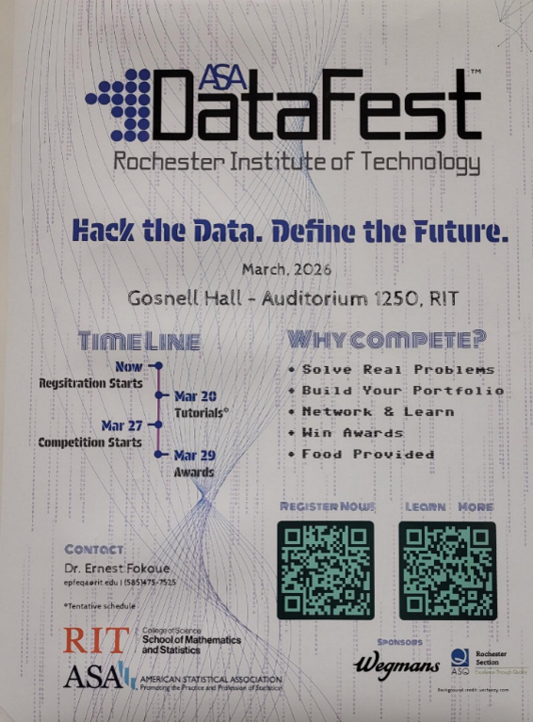

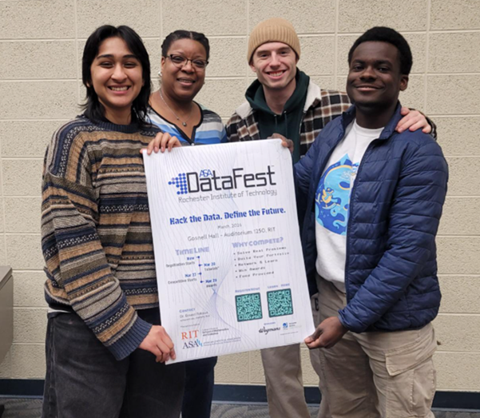

GRQC Day of Quality (April 20–30)
The Greater Rochester Quality Council’s Day of Quality runs April 20 to 30 with activities focused on process improvement across organizations. The Day of Quality brings local quality experts together for an entire day working side by side with nonprofit staff. The result is a hyper-focused project that makes real differences in organizational processes, quality, and performance excellence. Plus, it is a lot of fun for everyone involved.
https://www.grqc.org/day-of-quality

ASQ World Conference — Orlando, FL (May 17–20)
The ASQ World Conference takes place May 17 to 20 in Orlando, Florida. It is a prime opportunity for professional development, networking, and learning about global quality trends. Attendees can choose from dozens of technical sessions, workshops, and certification prep classes covering topics such as AI in quality, risk management, and sustainability in operations. If you plan to attend, consider coordinating with other chapter members to share notes and bring back insights for a post-conference debrief meeting.
https://asq.org/conferences/wcqi
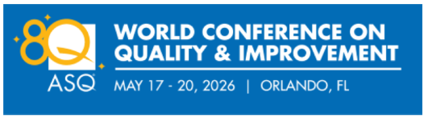

GRQC Performance Excellence Awards — Submissions are now open for the GRQC Performance Excellence Awards through May 31. Nominate organizations or teams that demonstrate outstanding quality performance and continuous improvement. The awards recognize measurable results across categories like process improvement, leadership, and customer focus. Winners receive regional recognition and feedback from experienced examiners. Preparing a submission can also serve as a valuable self-assessment exercise for teams sharpening their performance metrics and improvement plans.

Machine Tool Open House — OptiPro (June 10–11)
OptiPro’s Machine Tool Open House is June 10 to 11. The event will feature demonstrations of precision equipment and discussions on process control and measurement, a great chance to see quality engineering applied directly on the shop floor. Attendees can observe live machining demonstrations, speak with application engineers about fixturing and metrology solutions, and learn best practices for statistical process control in precision manufacturing. This open house is well suited for engineers, quality managers, and students interested in tight-tolerance production and inspection techniques.
https://www.optipro.com/technology-open-house/

ASQ Fall Conference — Save the Date (November 2026)
Mark your calendars. The ASQ Fall Conference returns to the RIT Conference Center in November 2026. Expect practical sessions on quality tools, leadership, and industry case studies, with details and registration information to follow. Planned tracks include process improvement, quality management systems, and data analytics applied to quality challenges. Sessions will be relevant for early-career professionals and seasoned practitioners alike. The conference will also feature a vendor area where attendees can connect with local suppliers of measurement, testing, and training services. We are looking for participants to join the planning committee and help make this a strong, engaging learning experience.

Welcome, New Members
Please join us in welcoming;
Stephen Allen, Jacqueline Hinneh, James Noah Ssemanda, Nathaniel Rose, Sahil Sharma, Chiara Duenas, Christopher Judd, Maimaiti Aji, Kobe Sanders, Haleigh Trayhern, Kara Stone, Philip Matthew Aaron, Sarah Carlson, Hanan Chehab, Elise Angelo, Greg Ferris, Theresa Burns, Una Moneypenny, Clare Russell, Tobias Kiebala, Justin Poulter, Zachary Orlowski, Michael Faucz, Kimberly Gebo, Thomas Owens, Ivanka Driankova, Maureen Freyn, Katrina Mengs, Diana Schaeffer, Lauren Smith, Ronald Dietz, Deedra Dowdle, David Hahn, and Brian Zeberl to ASQ Rochester.

We look forward to their participation and contributions to chapter activities and events.
As always, there are opportunities for your input and participation across our seven swim lanes: Operations, Communication, Membership, Program, Education, Philanthropic, Conference, and Student Chapter. Please reach out to any swim lane leads, or to me directly, to offer your skills, suggest topics, or volunteer for upcoming activities. We look forward to your involvement and to a productive, energizing spring together.

Humbly serving,
Franklin I. Allen.
Chair, ASQ Rochester

